**Recommender systems**

Capture patterns of people’s behavior and use it to predict what else they might like.

**Applications:**

Amazon – Suggesting books.

Netflix – Suggesting movies

Facebook, linkedIn – Suggesting friendships

Music apps , youtube – suggest videos or album that the user may like.

Advantage:

Broader exposure.

Marketing strategy by attracting the customers with suggestions.

Types:

* Content based (like some me more)
* Collaborative (tell me what’s popular among my friend’s circle)

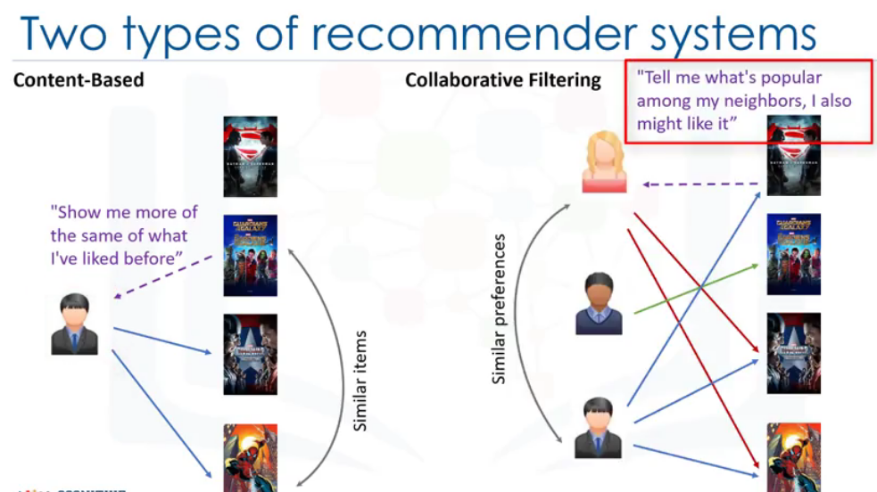

**Implementation techniques:**

* **Memory based**
* **Model based**

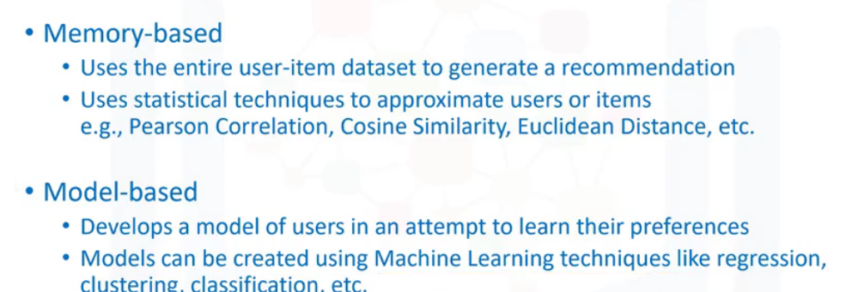

**Content Based recommender systems:**

Makes suggestions based on user profile, typically user’s taste based on clicks or likes.

Suggestions are based on similarity in items. Similarities are measured based on content, genre and so on.

**Methodology:**

1. **Encode the movies using one hot encoder methodology (Movies matrix)**
2. **Calculate the weighted genre matrix by multiplying user rating and movie matrix**
3. **Sum the weighted genre matrix based on each genre.**
4. **Find the weighted average for each genre.**

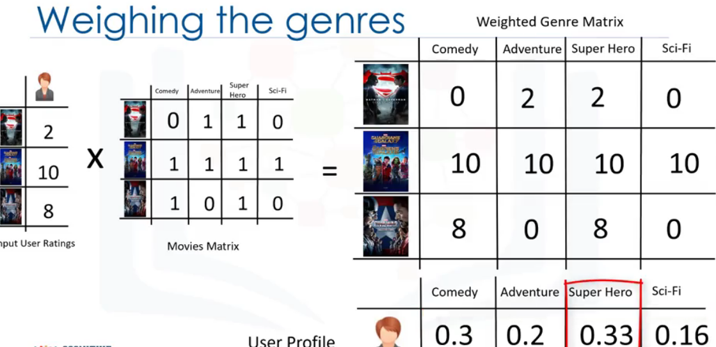

**Steps to find which movie the user prefers more among the three:**

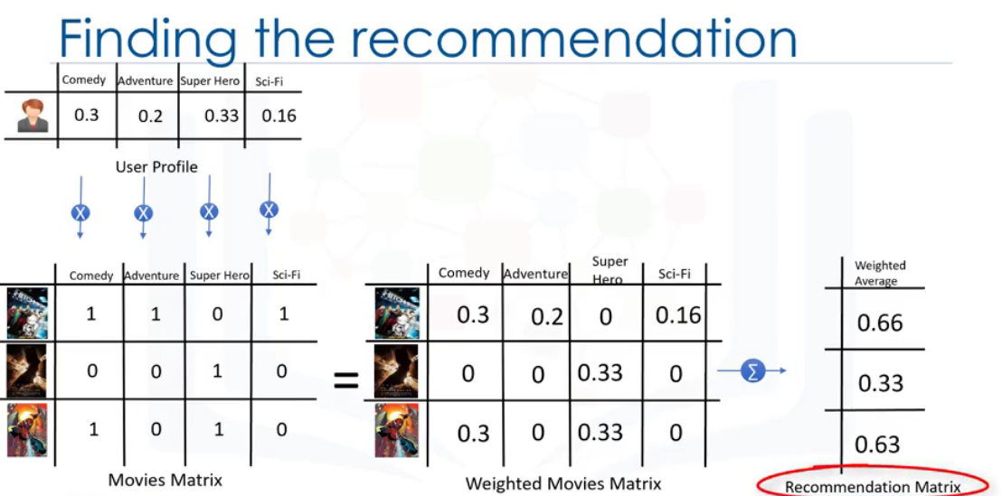

**Content based doesn’t give ratings for genre which the user hasn’t seen.**

**Collaborative filtering:**

**User based filtering –** based on user similarity or neighbor

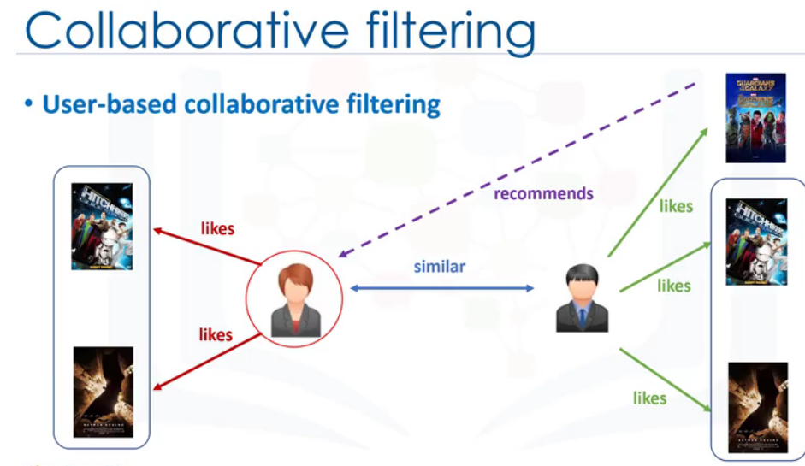

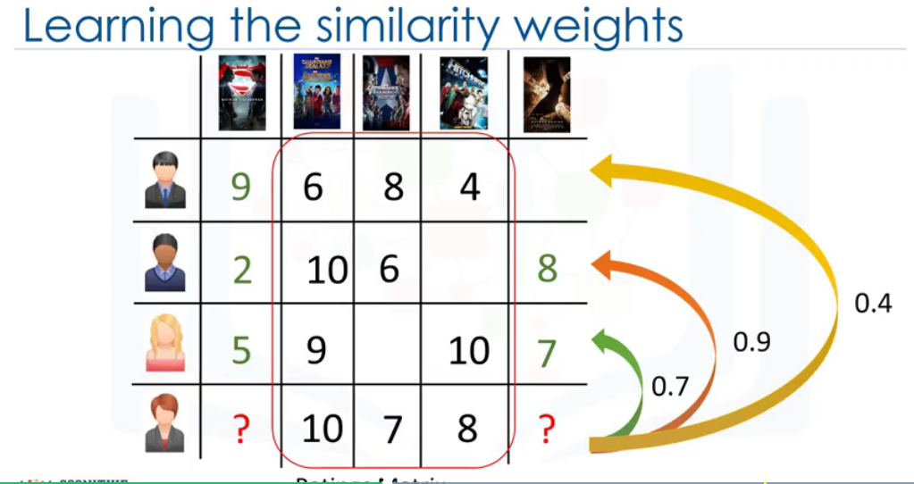

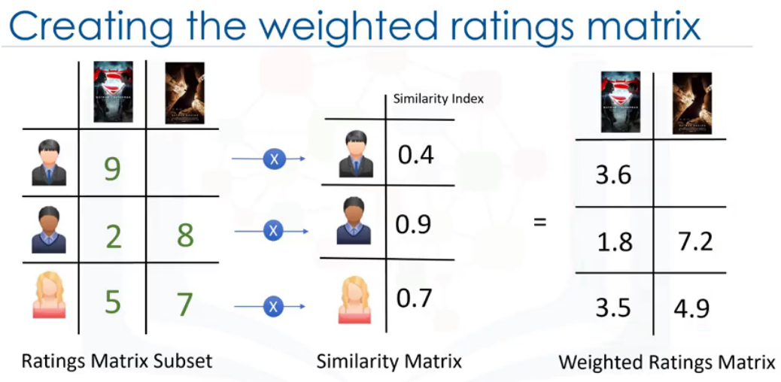

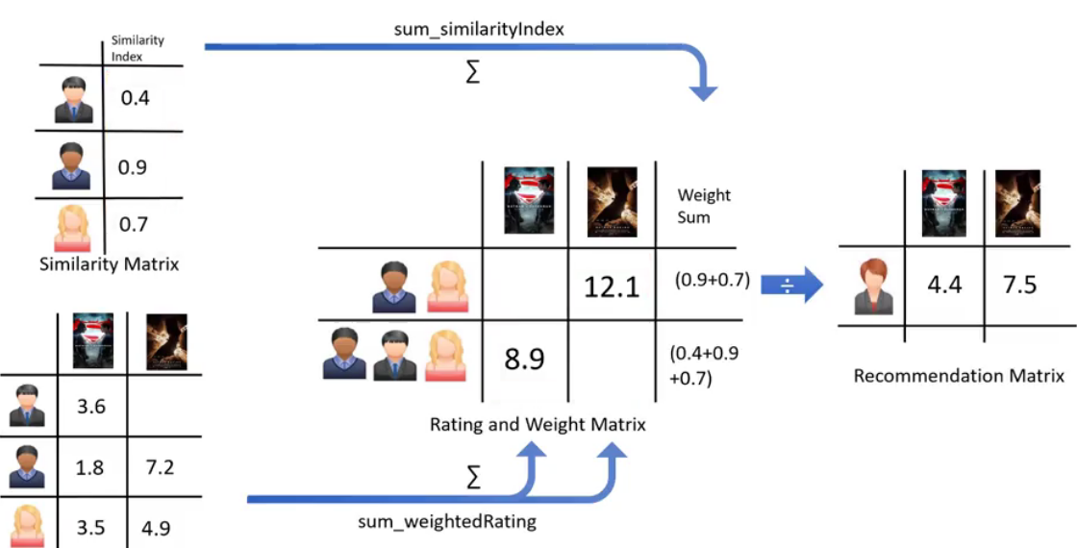

**Item based filtering –** based on similarity in items.

**Similar items build neighbourhod not based on content of item but by based on the ratings the user has given to the item.**

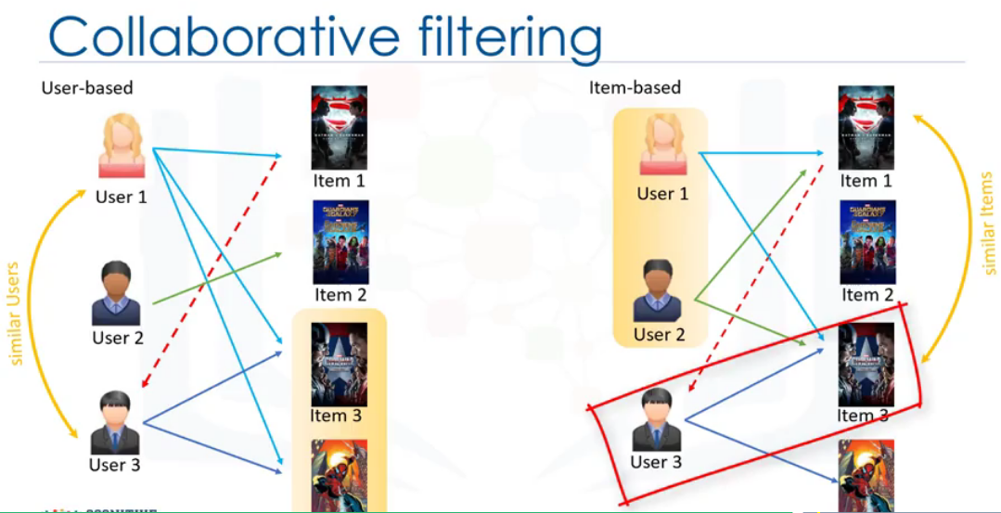

**Dataset link for coding:** https://s3-api.us-geo.objectstorage.softlayer.net/cf-courses-data/CognitiveClass/ML0101ENv3/labs/moviedataset.zip

# References

Aghabozorgi, S. (n.d.). *coursera.* Retrieved from www.coursera.org: https://www.coursera.org/learn/machine-learning-with-python